**KEY – MATH 1201 Final Exam – NLESD - June 2014**

**Part II**

**Total Value: 35 marks**

Value

4 36. This composite object is a rectangular pyramid on top of a rectangular prism. Find the height of the rectangular pyramid and use this to help determine the volume of the composite object. (answers to the nearest tenth)

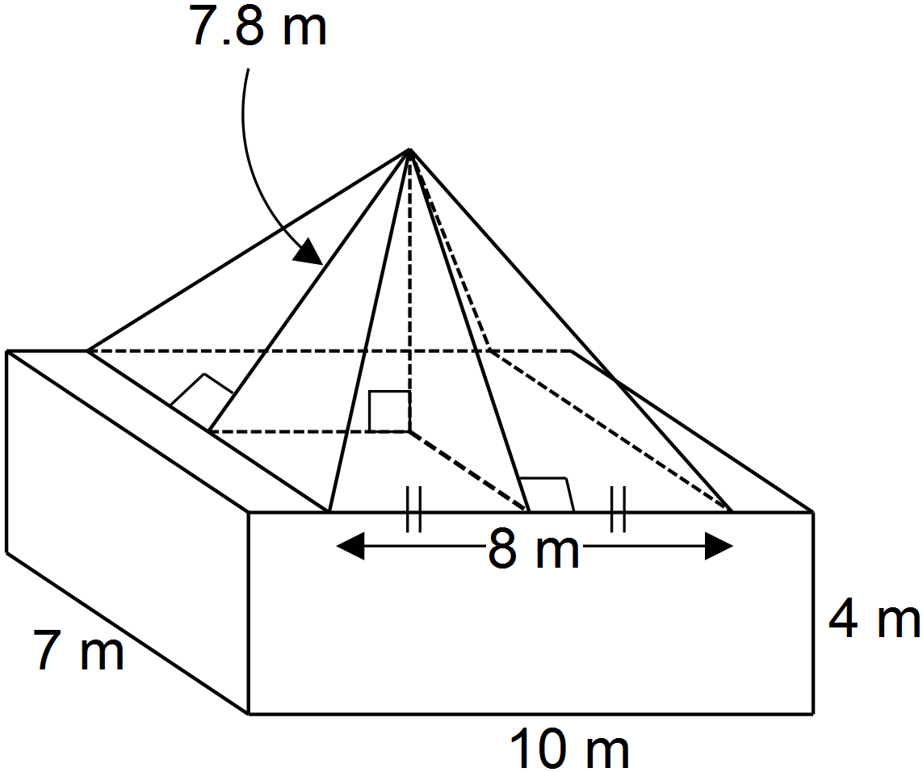



4 37. Determine the value of x to the nearest tenth of a metre.

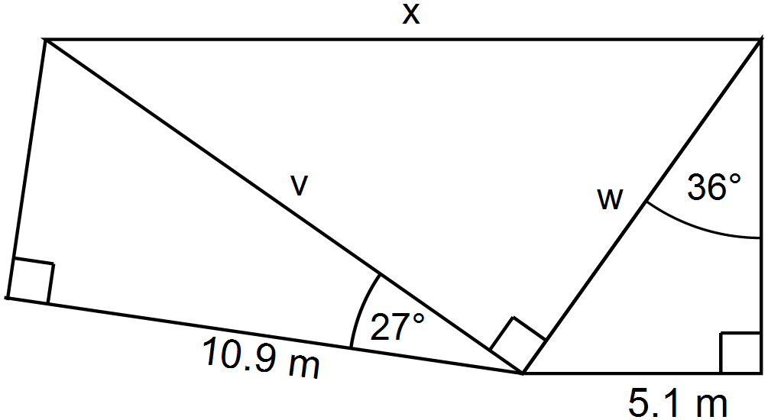



4 38. Simplify completely: (Note: Answers should have only positive exponents):





3 39. The volume of a cube is . Determine the surface area of the cube.

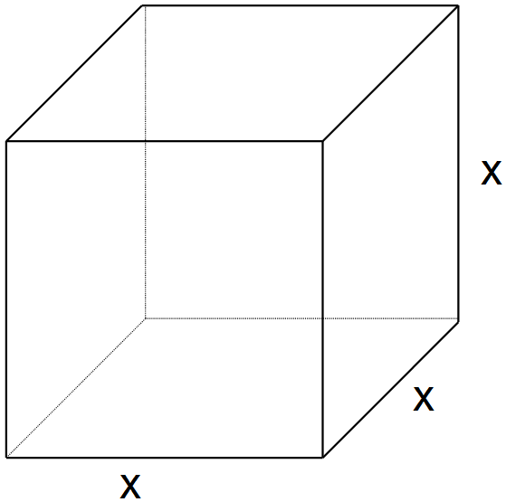



3 40. Factor completely: 



2 41. Expand and simplify: 

|  |  |
| --- | --- |
|  |  |

3 42. Determine the simplified expression that would represent the area of the shaded region.

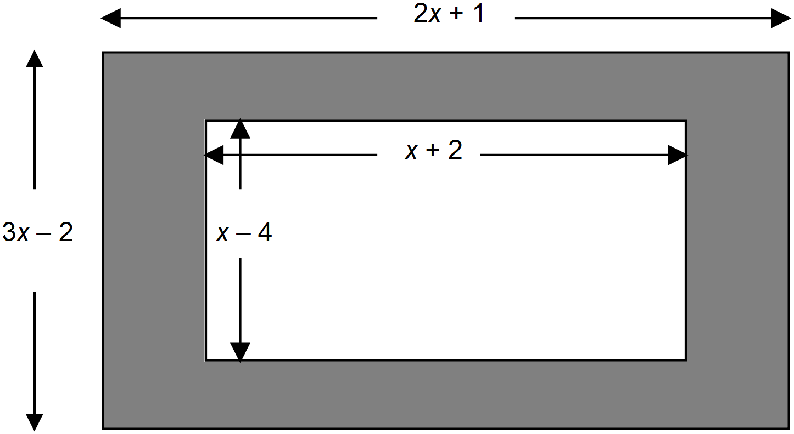

4 43. Determine the x and y intercepts of the function defined by  where  and sketch the graph of the function.

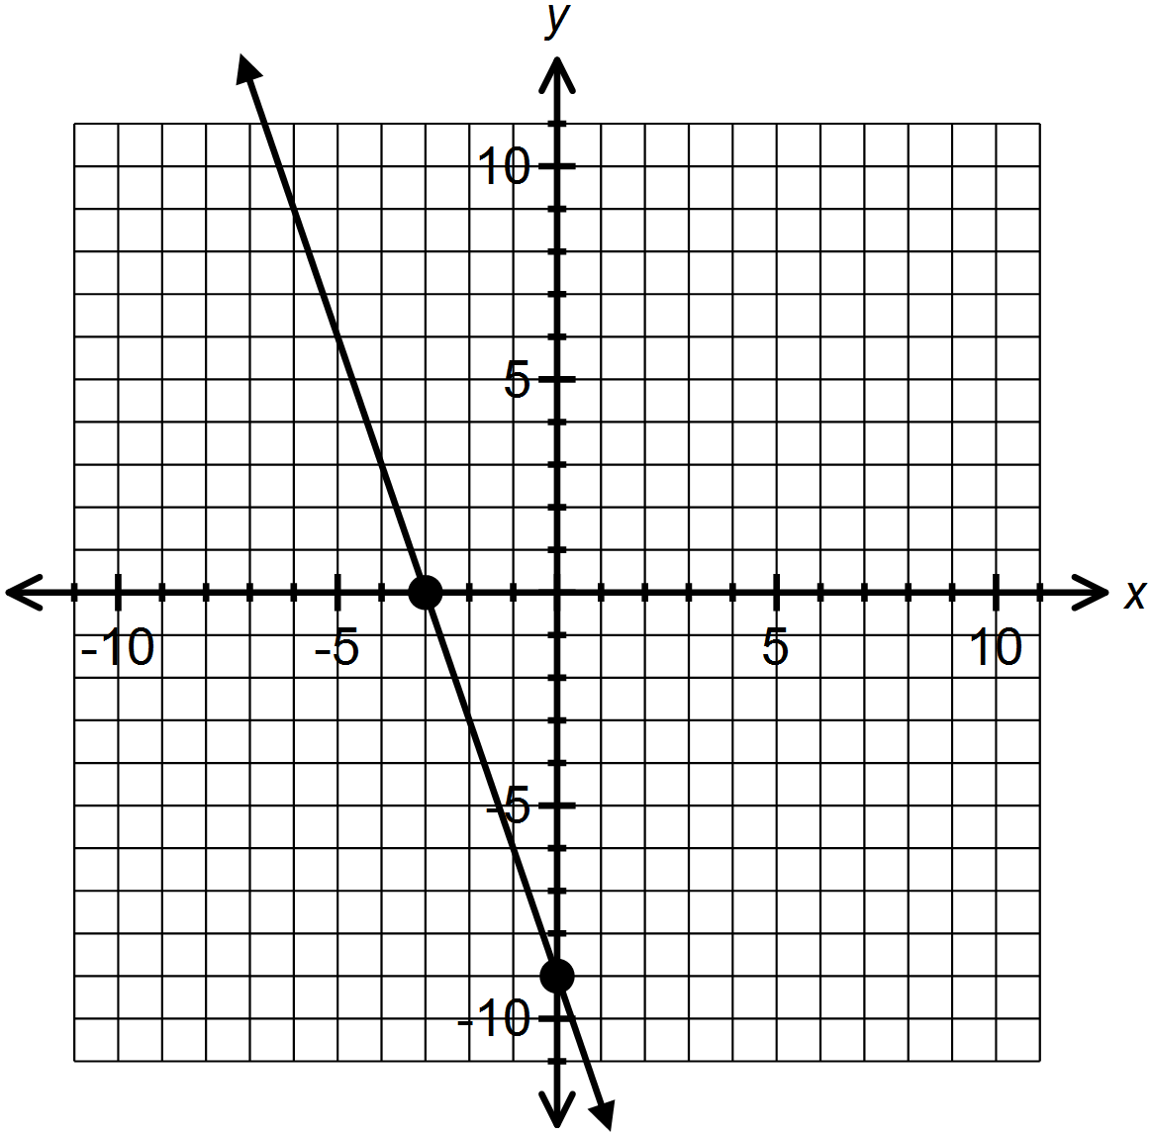



(NOTE: students could also graph it first using y=mx+b and then read off and list the intercepts)

44. A line passes through the points  and .

2 A) Determine the equation of the line in slope-intercept form. (i.e. )

2 B) Determine the equation of the line in slope-intercept form that passes through  and is perpendicular to .



4 45. Solve this system:



**KEY – MATH 1201 Final Exam – NLESD - June 2014**

|  |
| --- |
| 1. A |
| 1. D |
| 1. B |
| 1. B |
| 1. A |
| 1. B |
| 1. C |
| 1. D |
| 1. A |
| 1. C |
| 1. C |
| 1. B |
| 1. B |
| 1. C |
| 1. B |
| 1. C |
| 1. D |
| 1. D |
| 1. C |
| 1. C |

|  |
| --- |
| 21. A |
| 22. D |
| 23. A |
| 24. A |
| 25. D |
| 26. A |
| 27. D |
| 28. A |
| 29. C |
| 30. A |
| 31. D |
| 32. C |
| 33. B |
| 34. B |
| 35. D |